Advanced Exploitation Lab StepsStep 1: Environment
Setup and Initial Reconnaissance
1.1 Verify Metasploitable2 and Kali Linux VMs
Power on both VMs.

On Kali Linux terminal, check network connectivity and IP addresses.

Command:
Ifconfig
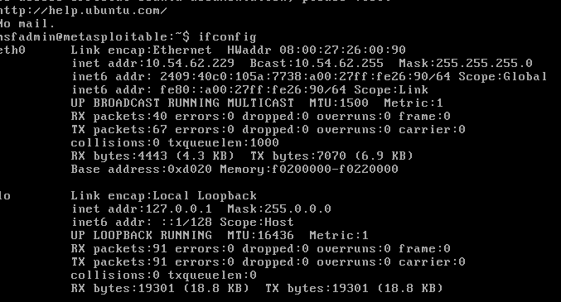
Kali Linux IP, 10.54.62.229.
On Kali, ping Metasploitable2 IP:
ping -c 4 192.168.1.100

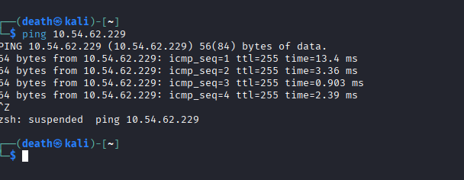
1.2 Run Nmap Service Scan on Target
In Kali terminal, run:

nmap -sV -A -vv -T4 192.168.1.100
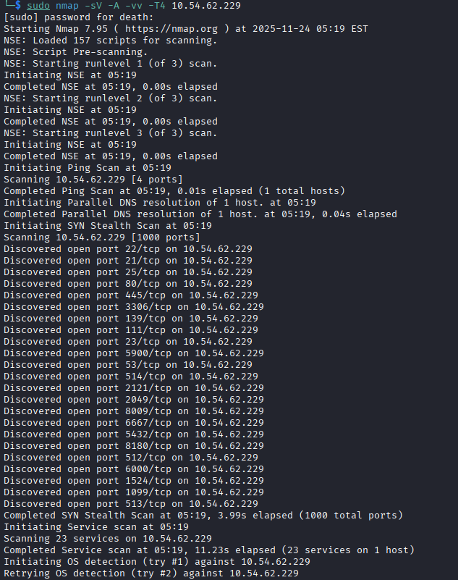
1.3 Document Reconnaissance Findings
Create a Google Docs or local text file and note:

Target IP: 10.54.62.229

Date and time of scan

Open ports with services

OS information if detected

Example table format:
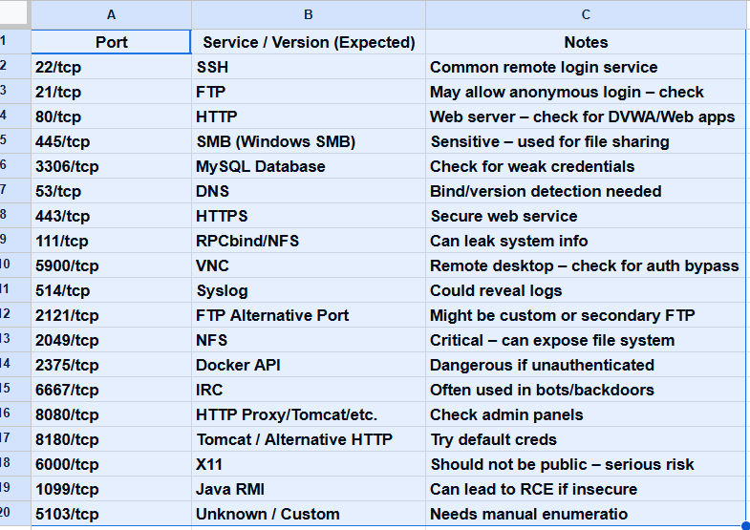

Exploit Chain Launch Using Metasploit :-
FTP:
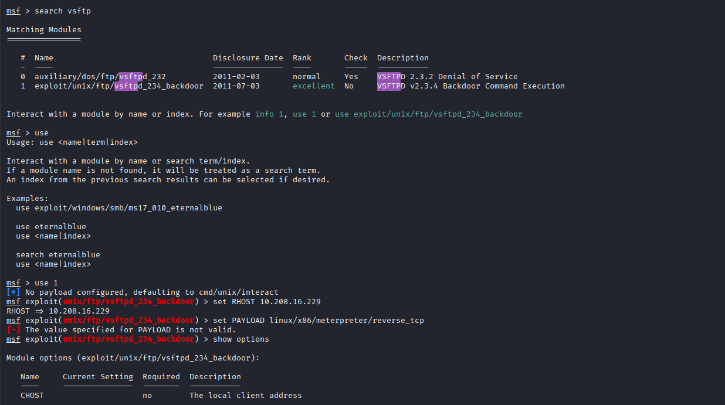

Document Exploit Chain Details:-
POC Python Script
ExploitDB Installation
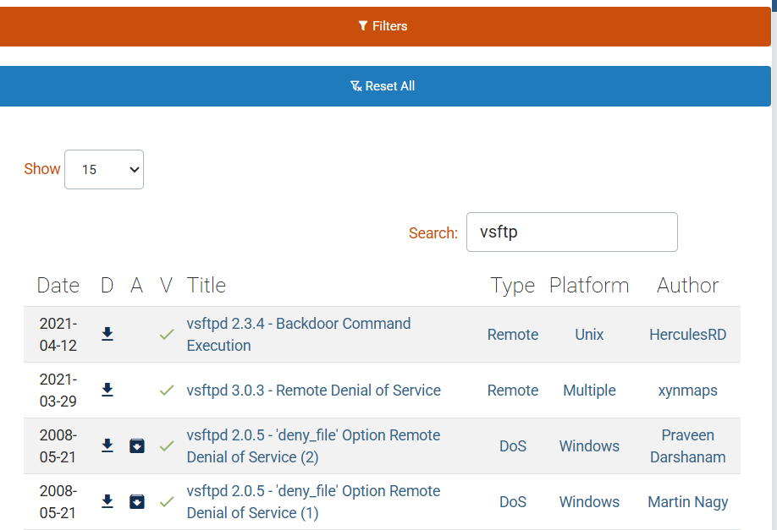
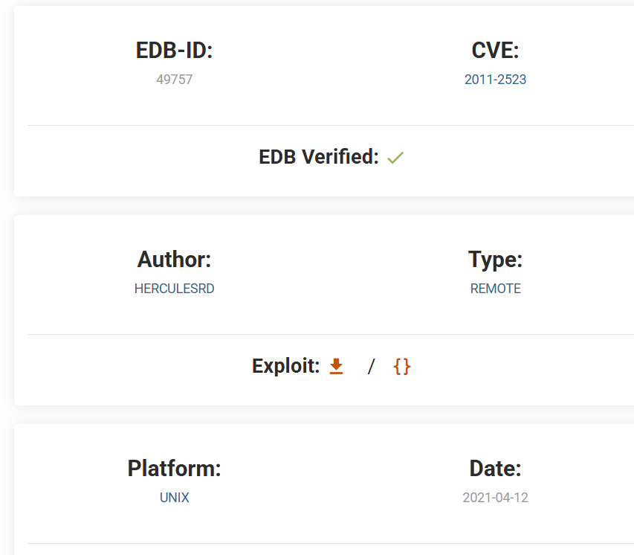
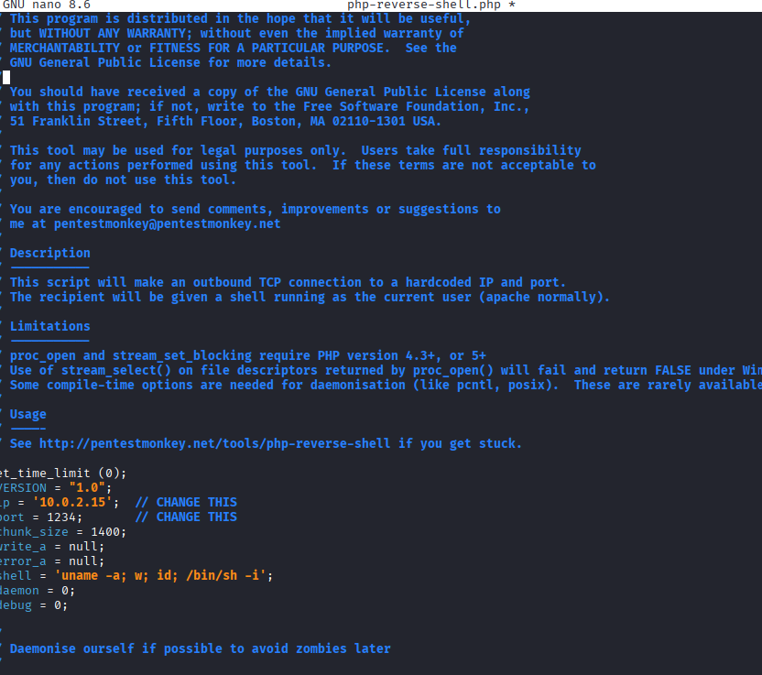
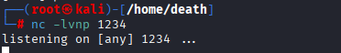

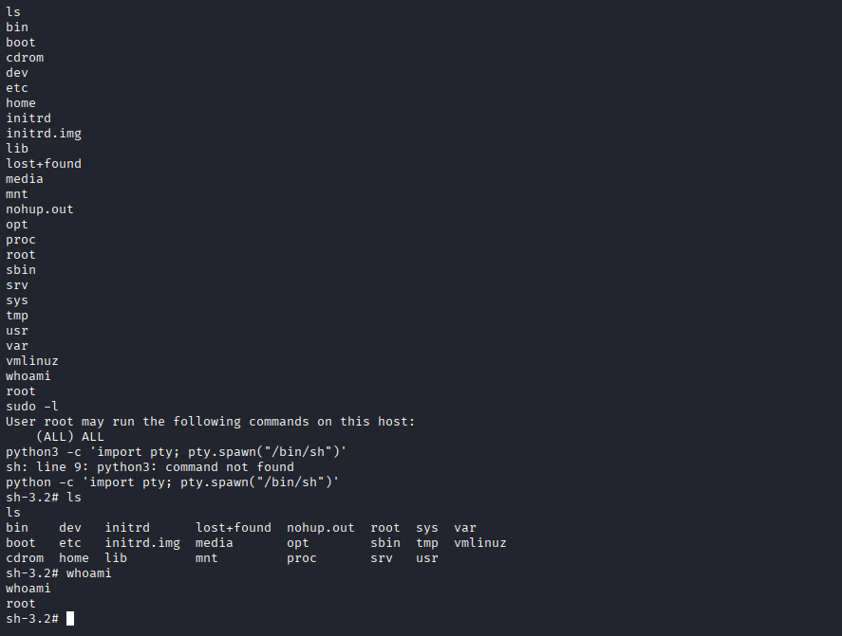

Summary:-
“Modified the Python PoC by setting the target IP to 192.168.1.100 and changed the web endpoint path to /vulnerable.php. Replaced the payload command with uname -a to verify remote code execution. Adjusted timeout parameters to improve script reliability in the lab environment.”

2 WEB APPLICATION PENTESTING

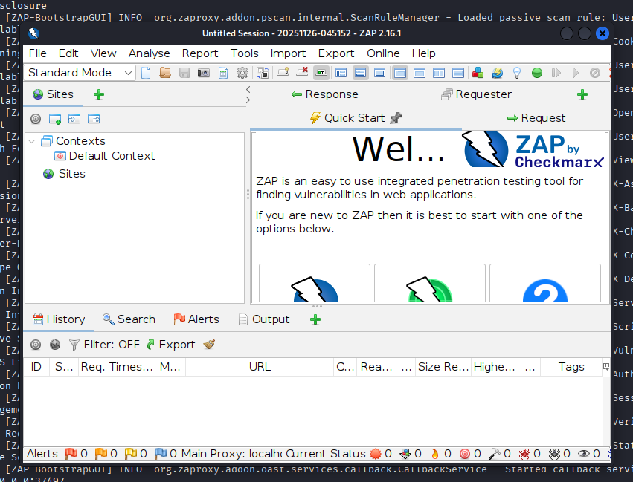
SQL
'1' OR '1'='1'
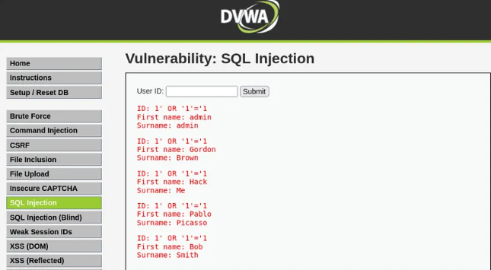

UNION-Based SQL Injection:
?id=1 UNION SELECT user, password FROM users#
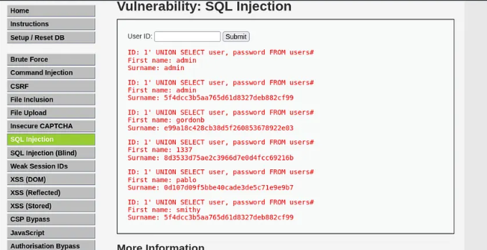

XSS Refected
<script>alert(‘Reflected XSS’)</script>
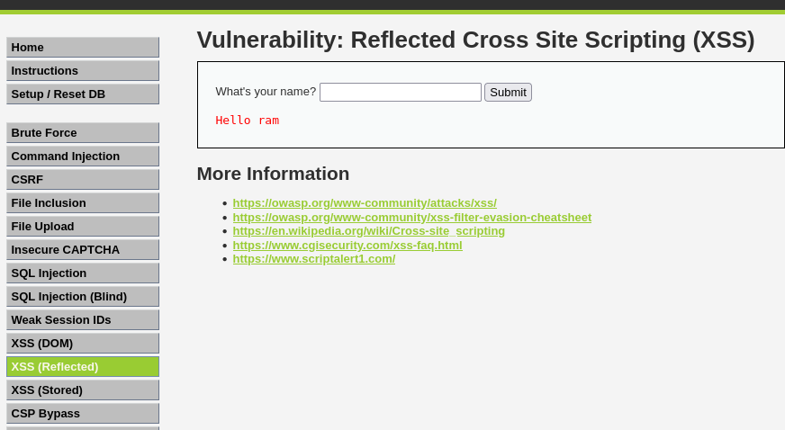
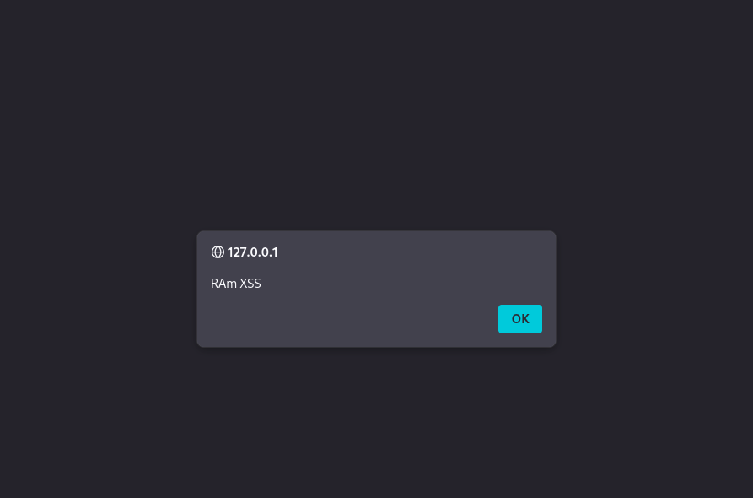

XSS Stored
<script>prompt(‘Stored XSS’)</script>
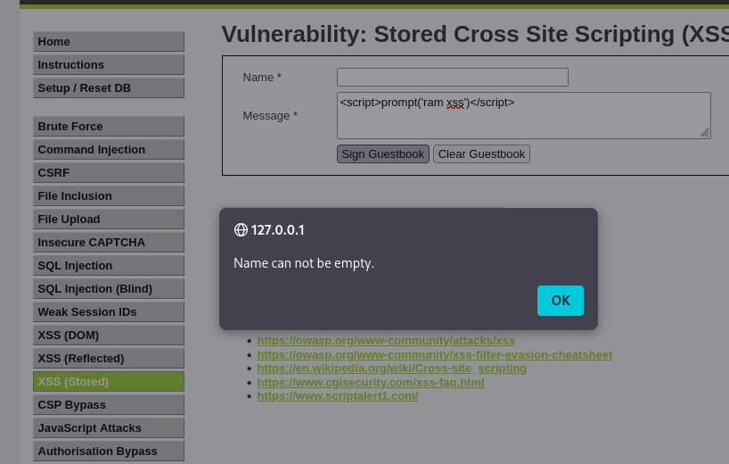

Document Finding
Logging vulnerability found:
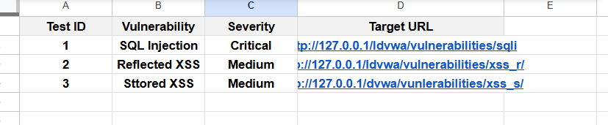

Write a 50-Word Summary
Example:
Manual and automated scanning with OWASP ZAP and sqlmap identified critical SQL Injection in login and medium severity reflected XSS in search functionality. Immediate sanitization and parameterized queries are recommended to mitigate these vulnerabilities.

Create Network Attack Path Diagram with Draw.io
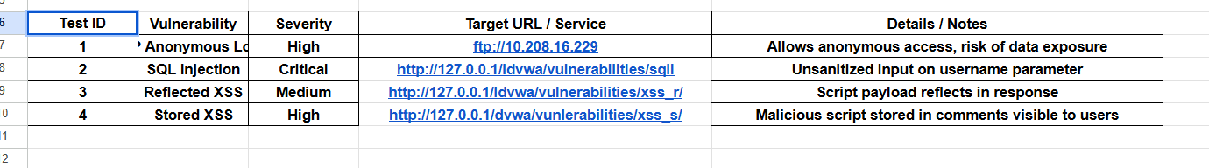

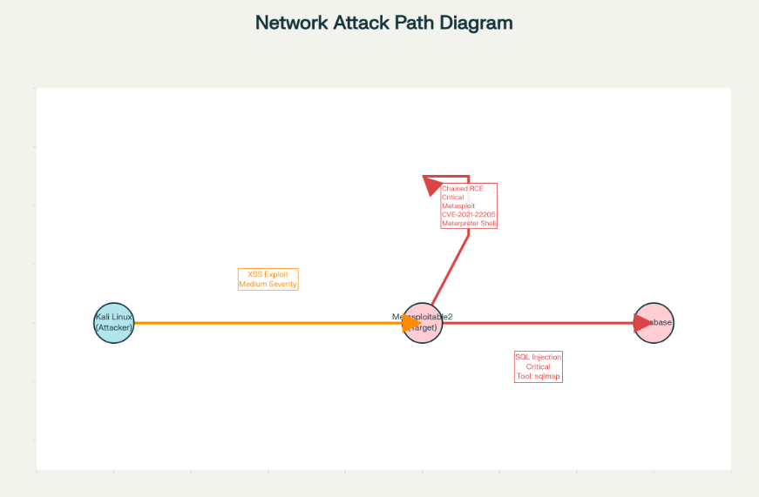
During the penetration test, critical vulnerabilities were identified in the target web application, including SQL Injection and Remote Code Execution risks. These issues could allow unauthorized access and data compromise if not addressed promptly. The team recommends immediate remediation focusing on input validation, patching, and enhancing authentication controls. Timely actions will reduce the risk of exploitation and protect sensitive information.

Post-Exploitation and Evidence Collection

14.1 Privilege Escalation Using Meterpreter

After obtaining a Meterpreter session, attempt local privilege escalation to gain higher system privileges.

Use Metasploit’s local exploits:

bash
use exploit/windows/local/always_install_elevatedset SESSION 1 # Replace with your active session IDexploit

Confirm escalation success by checking user privileges:

bash
getuid

14.2 Capture Network Traffic with Wireshark

Launch Wireshark on Kali Linux:

bash
wireshark

Start capturing on the network interface connected to your lab.

Filter traffic by target IP:

text
ip.addr == 192.168.1.100

Capture HTTP traffic or other relevant data during exploitation.

Save capture as a .pcap file with date/time.

14.3 Hash Evidence Files

Generate SHA256 hash for collected files or logs to maintain integrity:

bash
sha256sum filename.pcap > filename.pcap.sha256

Store hash files with evidence to prove no tampering.sss

14.4 Document Evidence Collection
Create a table to log evidence:

Evidence Collection Summary (50 words)
Network traffic was captured during exploitation phases using Wireshark and stored securely. Local privilege escalation was attempted and verified through user privilege checks in Meterpreter. All evidence files were hashed and logged to ensure integrity and authenticity for reporting and possible forensic review.

